***FREE***

***REIKI***

***TREATMENTS***











On DAY

**DATE**

*Location*

**RAW event details here**

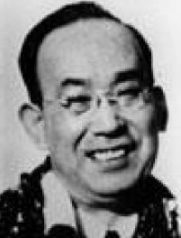

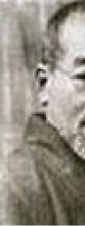

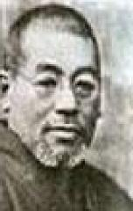

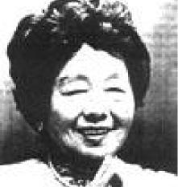

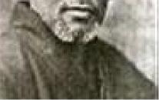



r

***Chuijiro Hayashi***

***Mikao Usui***

***Mrs. Takata***

Practitioners

**Enjoy the benefits of Reiki**

**available to members of**

**-**

Business Name

**the community. It is hoped that event organizers will   
endeavour to raise funds for charity and/or research   
into the benefits of REIKI - and what a great way to   
promote the system of Reiki, providing free short   
Reiki treatments to the public at large nationwide.**

& Contact

Details

**NATIONAL REIKI AWARENESS WEEK**

**–**

***put your dates here***